6.83: See Problem 6.82. Gravity does positive work, while friction does negative work. Setting the net (negative) work equal to the (negative) change in kinetic energy,
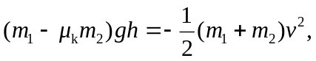
and solving for 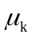 gives
